Министерство спорта и туризма Республики Беларусь

Белорусский государственный университет физической культуры

Кафедра иностранных языков

Г.В. Жулкевская

BASKETBALL

Учебное пособие по английскому языку
для студентов II курса

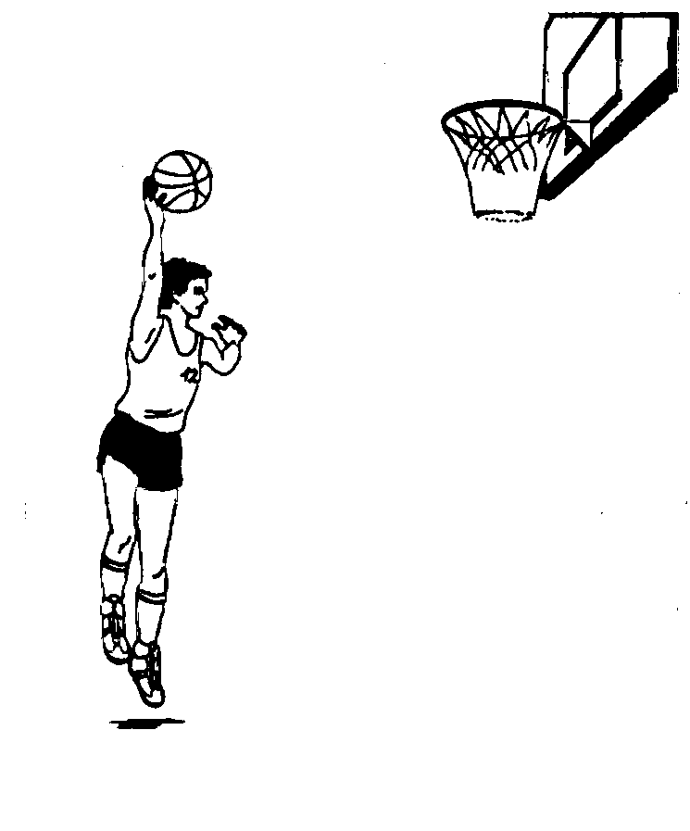

Минск 2004
УДК 802.0(035.5)
ББК 81.2 Я73
Ж87

Рецензенты: Карпышева Н.М. − к.п.н., доцент
Кротов В.Я.. − к.п.н., доцент кафедры спортивных игр БГУФК

Настоящее учебное пособие является уроком−темой курса "Английский язык" для студентов учебных заведений физкультурного профиля. Его цель − содействовать профессионально−ориентированному обучению студентов иностранному языку (английскому): приобретению знаний терминологической лексики по теме "Баскетбол", навыков общения в профессиональной деятельности и чтении литературы по специальности.
Учебное пособие составлено в соответствии с требованиями программы по английскому языку для неязыковых вузов.
Пособие дает возможность изучить основную терминологическую лексику по баскетболу.
При отборе лексики автор руководствовался принципом тематичности, сочетаемости, частотности употребления ее в современном английском языке. Большинство лексических единиц относится к широко употребительной спортивной лексике и базовой специализации "Баскетбол".
Текстовой материал знакомит студентов с баскетболом, техникой игры, оборудованием площадки, историей развития баскетбола, правилами судейства.
При отборе текстового материала в качестве основного критерия служила информативная ценность текста и их соответствие интересам студентов. Тексты взяты из оригинальных спортивных материалов.
Учебное пособие не претендует на полноту охвата всех реалий в области баскетбола, однако, оно должно расширить словарный запас учащихся; активизировать знания, умения и навыки, полученные на ранних этапах изучения английского языка, за счет их тренировки в различных видах речевой деятельности.
Материал рекомендуется проходить в порядке, изложенном в пособии.

Basketball
I. Discuss with your group-mates before you read the text:
- What do you know about basketball?
- How is basketball played?
II. Say:
- if basketball is popular in Belarus,
- if basketball is an entertaining sport only,
- what you know about the rules of the game,
- what one must do to become a good basketball player.
III. Study the vocabulary to text 1:
basket n корзина
basketball n баскетбол, баскетбольный мяч
shoot v бросать, забрасывать
shooter n игрок, выполняющий бросок
inflated part надутый (воздухом)
advance v вести мяч
dribbling n дриблинг
bounce v отбивать мяч (от пола)
score v забивать мяч, вести счет
level surface ровная поверхность
retrieve v вернуть себе, восстановить
rebound n отдача, v отскакивать
ball handler n игрок, владеющий мячом
Task I. Read the text trying to understand each word and expression
BASKETBALL
Basketball is a fast, exciting, and entertaining sport played between two teams, each consisting of five players. A team wins games by scoring more points than the opposing team. Players score by shooting a large inflated ball into a raised goal, called a basket, at one end of a basketball court. A player can advance the ball toward the basket only by dribbling (bouncing the ball) or by passing the ball to a team-mate. Each team also tries to prevent the other team from scoring.
Basketball was invented in 1891. By the mid-1900’s, it had become the world’s most popular indoor sport. Today, millions of fans crowd into gymnasiums and arenas to watch their favourite teams. Millions more watch games on television.
Basketball is a popular form of recreation as well as an organized team sport. As few as two players can play; all they need is a ball, a basket, and a level surface.
Basketball requires teamwork, quick reactions, and endurance. Tall players have an advantage because they can reach closer to the basket or above other players to shoot and retrieve the ball on the rebound. But smaller players also make contributions to their teams as shooters and ball handlers.
Vocabulary, Grammer and Speech Exercises
Ex. 1. Find Russian equivalents for the following English words and word-combinations:
- basket  - shoot  - advance  - dribbling  - passing  - level surface  - endurance  - advantage  - retrieve  10.rebound | - продвигаться  - вести мяч  - передача мяча  - выносливость  - забрасывать  - корзина  - ровная поверхность  - отскакивать  - преимущество  - вернуть себе
Ex. 2. Find English equivalents for the following Russian words and word-combinations:
забрасывать мяч, надутый мяч, ведение мяча, препятствовать другой команде, ровная поверхность, быстрые реакции, высокие игроки, вернуть себе мяч, владеющий мячом.
Ex. 3. Try to match these words with their meanings:
team record of points, made by a player or team
score number of persons playing together
inflate advance the ball bouncing
dribbling fill a ball with air
teamwork ability to endure
endurance combined effort
advantage act of contributing
contribution something useful or helpful to bring success in competition
retrieve bounce back after hitting
rebound get possesion of again
Ex. 4. Find the sentences with Participles in the text and translate them into Russsian.
Ex. 5. Translate the following prepositions in Russian:
between, into, at, toward, to, from, above, by, on, toward, between, to, into, above, at, on, from, between, from, on, above, into, by, between, at, from, on, into, above, toward.
Ex. 6. Insert prepositions (see the text):
- A team wins games ... scoring more points. 2. Players score ... shooting a ball ... a basket ... one end ... a basketball court. 3. A player can advance the ball ... the basket only ... dribbling or ... passing the ball ... a team-mate. 4. Each team tries to prevent the other team ... scoring. 5. Tall players can reach closes ... the basket or ... other players. 6. Smaller players also make contributions ... their teams.
Ex. 7. Make up special questions:
Model:
Basketball is a fast, exciting sport.
What kind of sports is basketball?
What sport is fast and exciting?
- Basketball is a popular form of recreation.
- Basketball is an organized team sport.
- The ball is inflated.
- Basket is a raised goal.
- Endurance is ability to endure.
- Inflated ball is a ball filled with air.
Ex. 8. Explain the terms used in basketball:
- basketball
- team
- shoot
- ball
- basket
- dribbling
- score
- level surface
- teamwork
- endurance
Ex. 9. Say:
- what kind of sports basketball is
- how many players there are in a basketball team
- when a basketball team win
- when players score
- how a player can advance the ball toward the basket
- what each team tries to do during the game
- what players are needed to play basketball
- what basketball requires
- what advantage tall players have in the team
- what contributions smaller players make to their teams
Ex. 10. Draw up a plan of the text.
Ex. 11. Retell the text: a) as it is; b) without details.
Task II. Read text 2 and study the playing court and backboards and baskets designs.
Text 2. Basketball equipment
1. Learn these words and word-combinations:
endline n лицевая линия
sideline n боковая линия
centreline n центральная линия
3-point line трехочковая линия
2-point field goal area двухочковая зона
3-point field goal area трехочковая зона
scorer’s table стол секретаря
team bench скамья запасных игроков
team bench area зона скамьи игроков
free throw штрафной бросок
free throw line линия штрафного броска
lane places размещение зон
free throw lane зона штрафного броска
neutral zone нейтральная зона
restricted area n штрафная зона, трехсекундная зона
backboard n щит
basket support ферма
ring n кольцо
rim n кольцо, ободок
padding n подушка
upside-down a перевернутый
bolt v скреплять болтами
technical equipment техническое оборудование
scoreboard n табло
scoresheet n протокол
game clock n часы для игры
stop watch секундомер
time-out watch n хронометрические часы (хронометр)
24 second device n прибор 24 секундной отметки
team foul indicator n указатель количества ошибок, допущенных командой
player foul markers n указатель количества персональных ошибок, допущенных игроком
count-down n часы обратного отсчета времени
elapse v прохождение времени, заканчиваться
digital v цифровой (табло)
suitable a подходящий, соответствующий
adverse a неблагоприятный
THE COURT
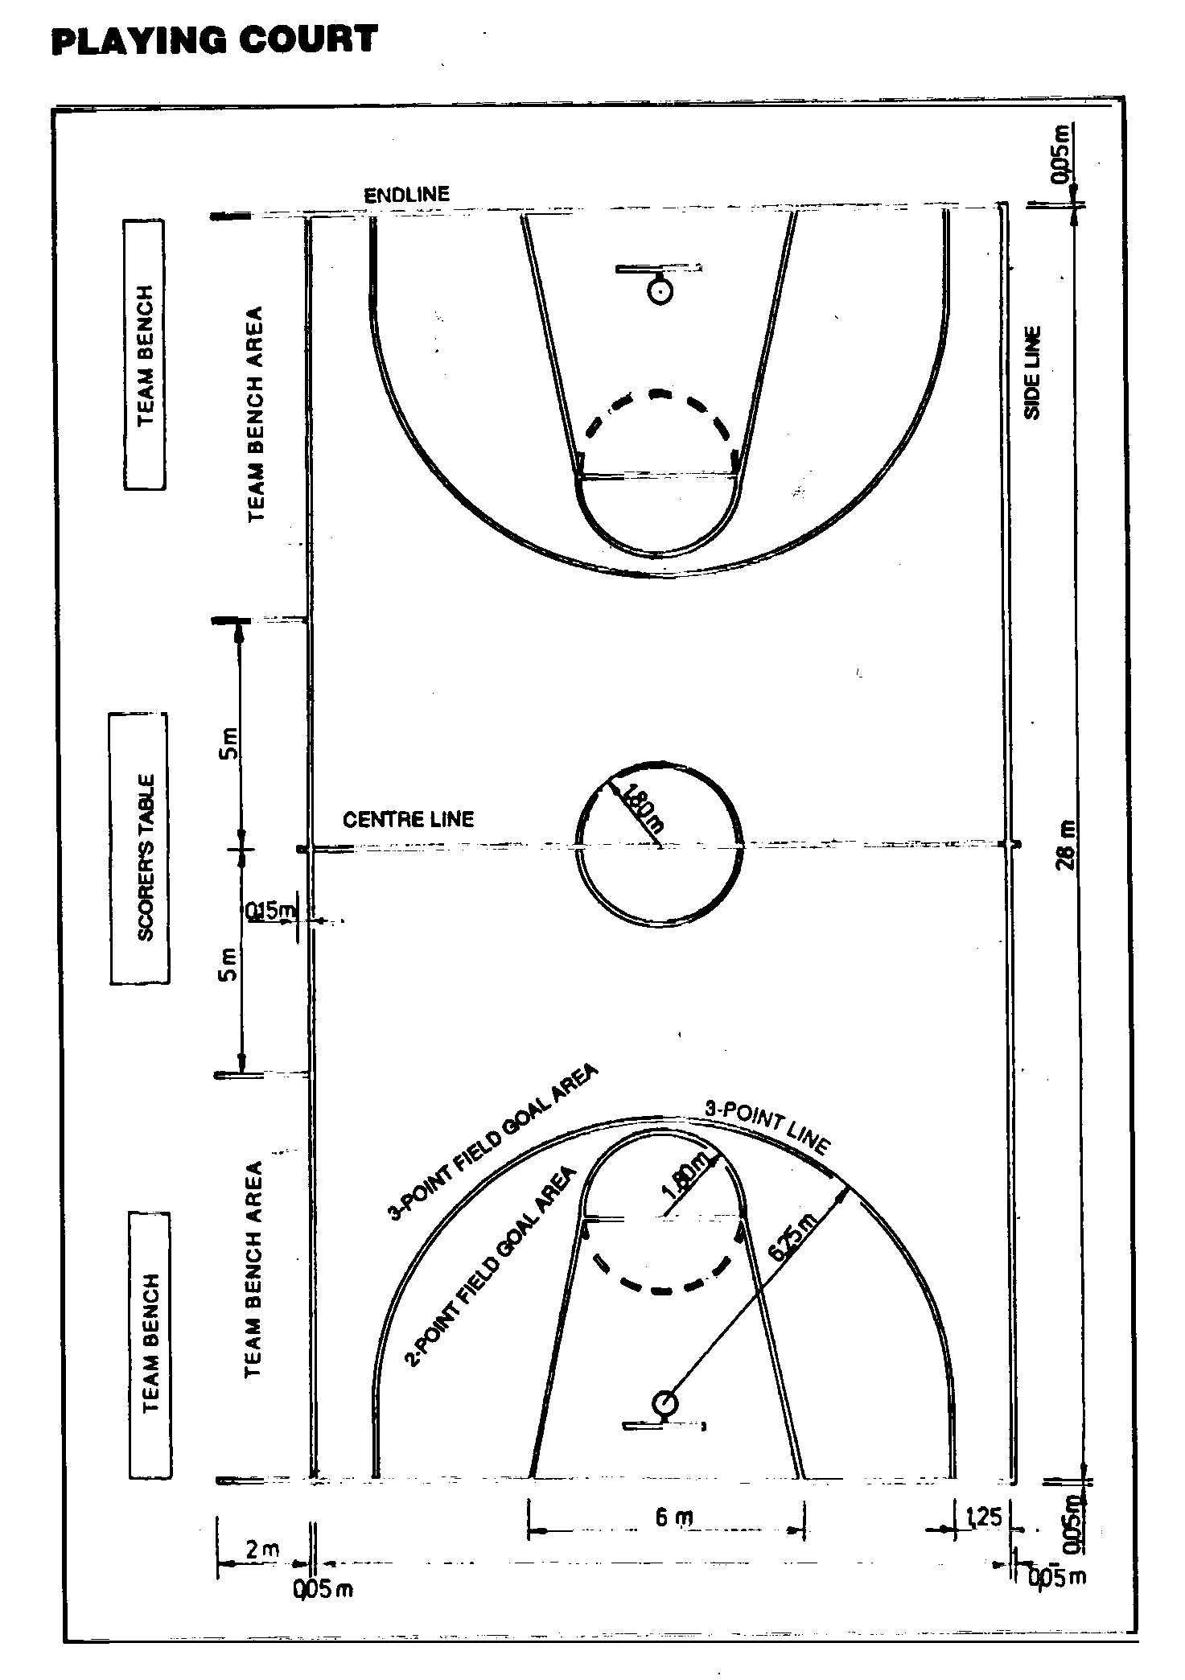
A basketball court is a rectangle divided into halfes by a centre linе.
A regulation basketball court measures 28 metres long and 15 metres wide. Most courts are made of wood. Various lines, 5 centimetres wide, divide the court into sections. For the names of these lines and the sizes and names of the sections, see the digrams.

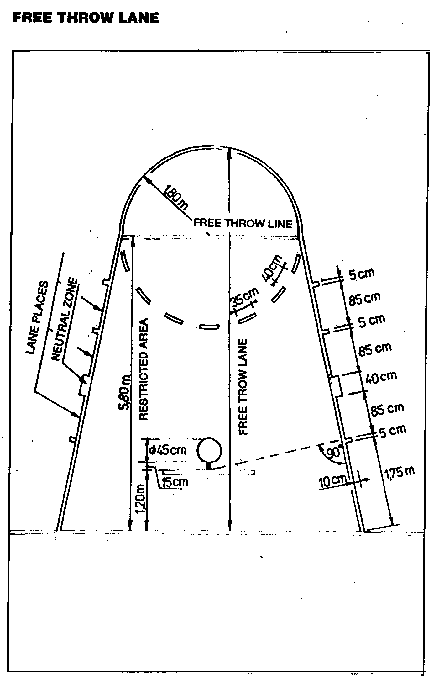

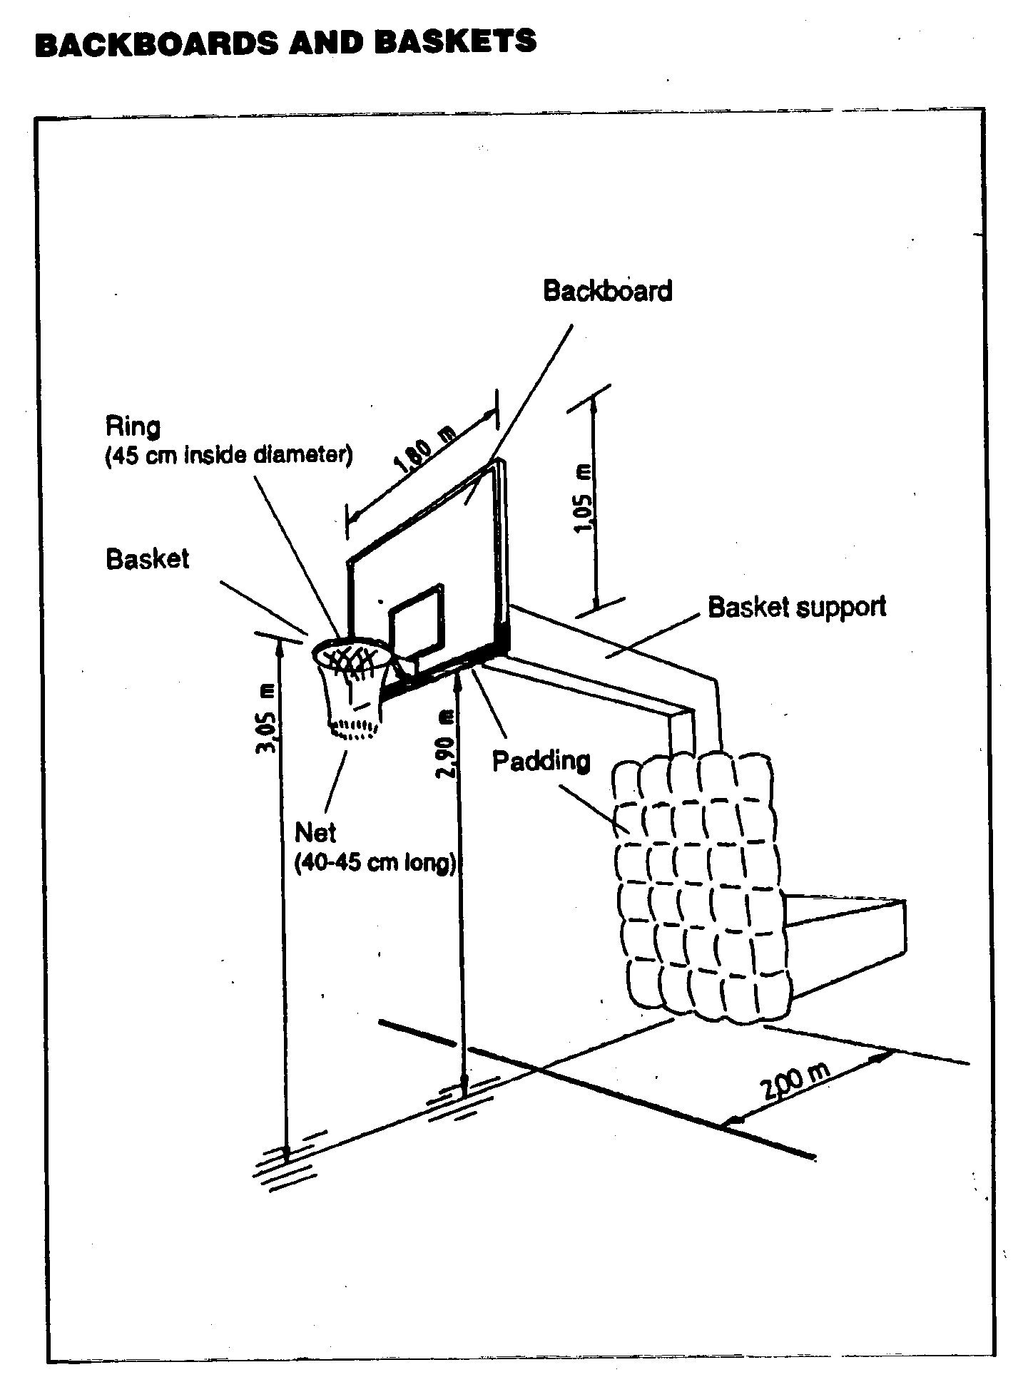
BACKBOARDS AND BASKETS
A basket and a backboard hang over each end of the court. Each backboard must be 120 centimetres inside the end line. The basket consists of a rim, net, and backboard support. The rim is a metal hoop 45 centimetres in diameter and not more than 20 millimetres thick. The rim is attached to a metal plate shaped like an upside-down L that is bolted to the backboards so it is parallel to the floor and 3.05 metres above it. Backboards are made of clear fibreglass or metal. The cotton or synthetic fabric net is attached to the rim and has a hole in the bottom large enough for the ball to drop through.
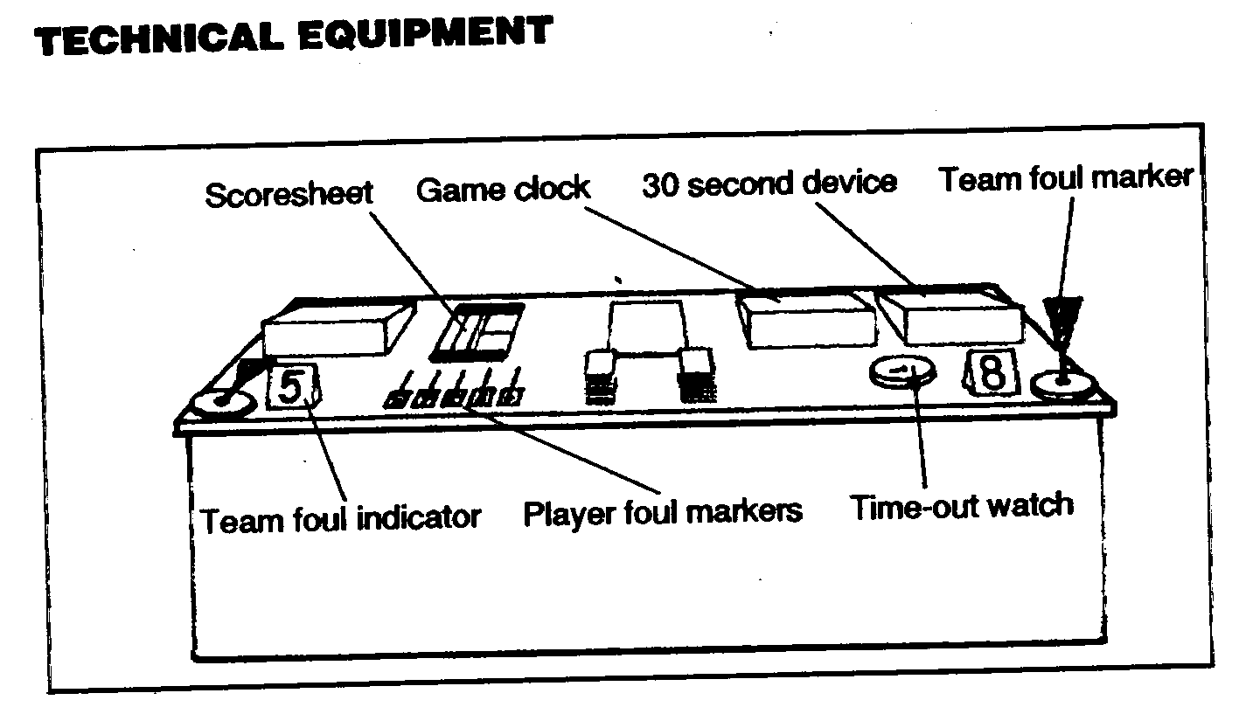
TECHNICAL EQUIPMENT
Game clock. The game clock is used for timing periods of play and the intervals between them. It can be stopped and subsequently continued from that time. It is recommended to use a count-down type of clock. When half time, full time, period or extra period has elapsed its signal shall automatically sound with a very loud signal. It shall be placed so that it is clearly visible to everyone involved with the game. In FIBA events at least during the last 60 seconds of each half or a period the amount of time remaining shall be indicated to the one-tenth of a second.
Time-out watch. Stop watch used for timing time-outs.
30 second device: The device shall be automatic, digital count-down type, indicating the time in seconds. The signal of the device should automatically sound with a very loud signal when it reaches ‘zero’, and should effect the stop of the game clock automatically as well. When the main clock stops, the device shall also stop. When the main clock starts, the device must have the capability to start manually (independently).
Scoresheet. It is the FIBA official scoresheet for recording game events.
Player foul markers: For indicating the number of fouls committed by a player. For games played in two halves of 20 minutes they shall be numbered 1 to 5 (1-4 in black, 5 in red). For games played in four periods of 12 minutes they shall be numbered 1 to 6 (1-5 in black, 6 in red).
Team foul markers: Both shall be red, and it shall be positioned on the scorer’s table when a team has reached the penalty status.
Team foul indicator: Suitable device to indicate the number of team fouls. The device shall stop at the number of team fouls (8) which indicates that a team has reached the penalty status.
The scoreboard: The scoreboard shall indicate the time remaining of a period as prescribed at game clock. It shall also indicate the points scored by each team, the fouls committed by each player on the team, and the number of team fouls from 1 to 8 for games played in 2 x 20 minutes and from 1 to 5 for games played in 4 x 12 minutes.
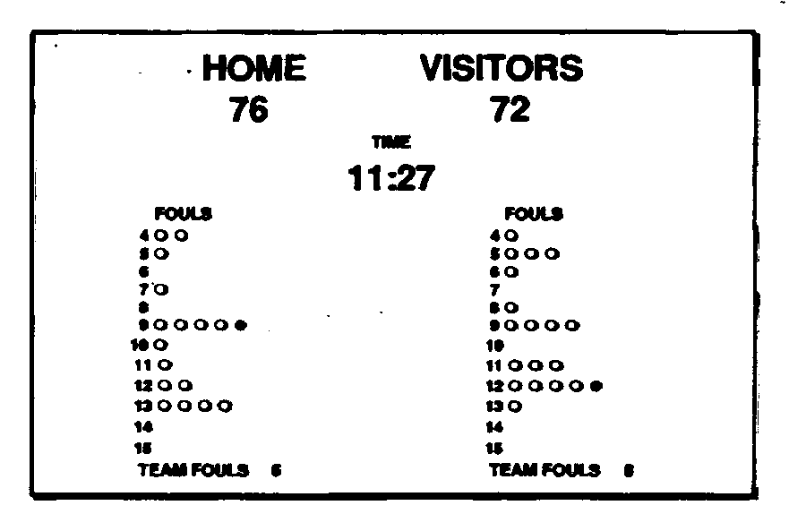
Signals. There shall be equipment for at least 2 different sounding signals: 1 for the timekeeper and the scorer, and 1 for the 30 second operator. For FIBA events three separate signals with distinctly different sounds are required for each person. All three signals shall be sufficiently powerful to be easily heard under the most adverse or noisy conditions.
It is strongly recommended that the 30 second device, an additional game clock and the bright red electric light be located above the backboard. The colours of the numbers of the 30-second device and the game clock shall be different.
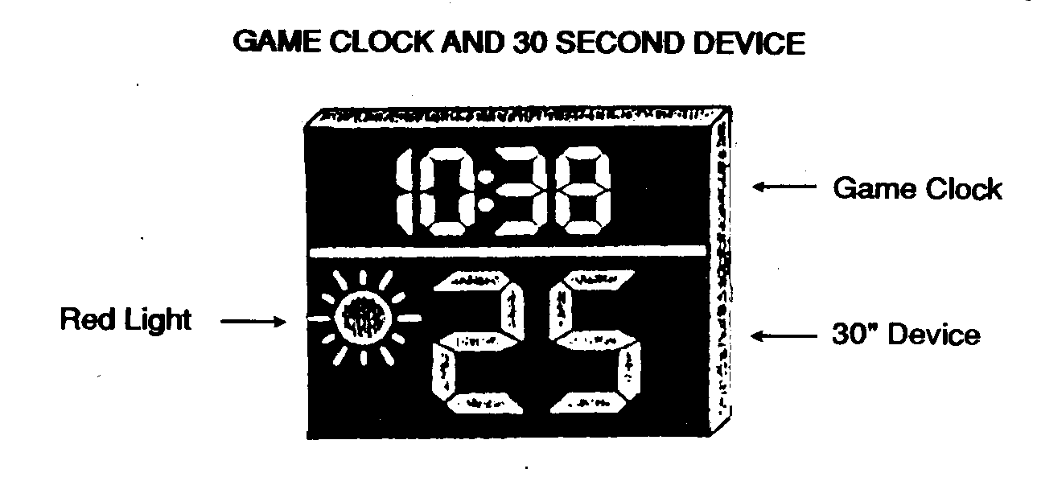
BALL SPECIFICATIONS
The ball shall be spherical and of an orange shade in colour. It shall be made with an outer surface of leather, rubber or synthetic material. For FIBA games the ball shall be made of leather and of a make approved by FIBA.
It shall be inflated to an air pressure such that when it is dropped into the playing surface from a height of 1.80 m measured from the bottom of the ball, it will rebound to a height of 1.20-1.40 m measured at the top of the ball. A standard basketball weighs between 600 and 650 grams and is between 75 and 78 centimetres in circumference.
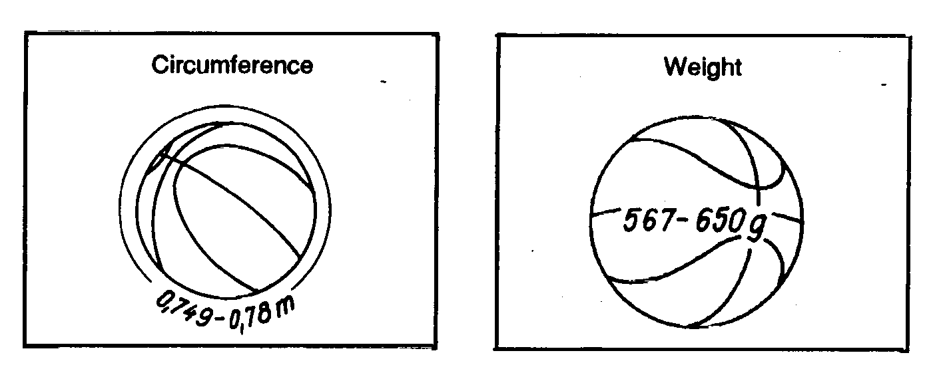
The home team shall provide at least 2 used balls that meet the above specification.
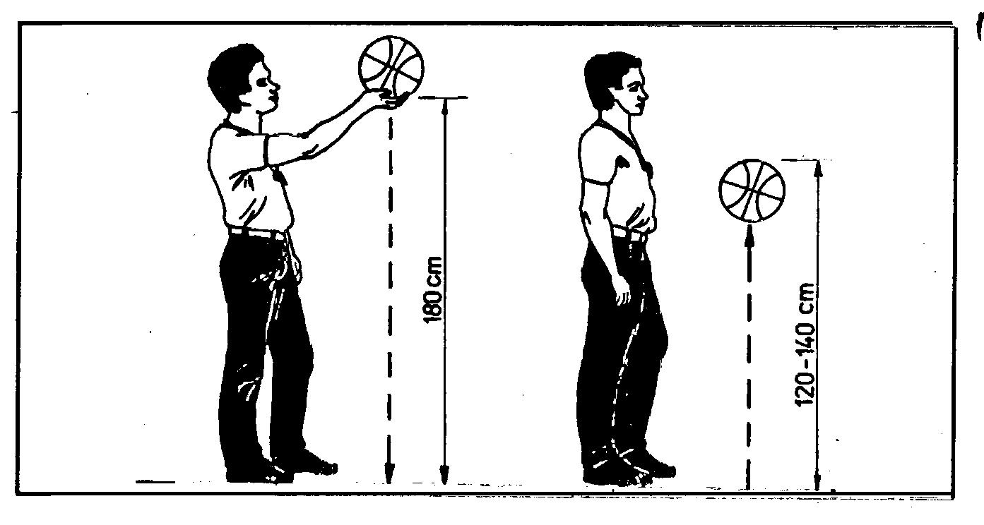
The referee shall be the sole judge of the legality of the ball and he may select a ball provided by the visiting team.
The referee may select one of the balls used by either team for the warm-up.
PLAYING UNIFORM
Shirts: shall be of the same, single, solid colour on both back and front. Striped shirts are not allowed. Each player shall be numbered on the front and back of his shirt with plain numbers of a solid colour contrasting with the colour of the shirt. The numbers shall be clearly visible: those on the back at least 0.20 high and those on the front at least 0.10 m high and not less than 0.02 m wide. Teams shall use numbers from 4 to 15. Players on the same team shall not wear duplicate numbers.
Male players must place (tuck) their shirts inside the shorts during the game.
Shorts: of the same, single solid colour shall be worn by all players of the same team.
T-shirts: may be worn under shirts, provided they are of the same single colour as the shirt.
Undergarments: that extend below the shorts may be worn provided they are of the same single colour as the shorts.
Teams must have a minimum of two sets of shirts, one light (preferably white) and the other dark in colour. The first team named in program (home team) shall wear light, and the second named team (visitors) dark coloured shirts. However if the two teams involved agree, they may interchange the colour of the shirts.
Players may not wear equipment which, in judgement of the official, is dangerous to other players.
All equipment used by players must be appropriate for basketball. Any equipment that is designed to increase a player’s height or reach or, in any other way, give an unfair advantage, shall not be permitted.
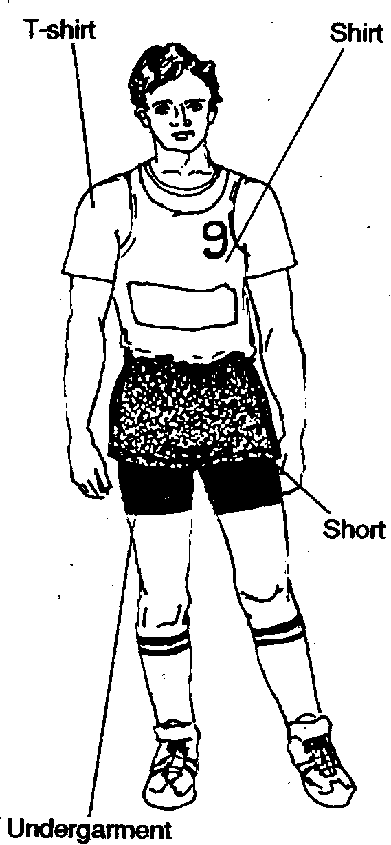
Vocabulary and Speech Exercises
Ex. 1. Put these words in the correct box:
shirt, playing court, basket, backboard, net, shorts, ring, padding, T-shirt, scoresheet, game clock, team foul markers, team foul indicator, under-garment, player foul markers, scoreboard 30 second device, basketball shoes, socks, hoop, rim, team bench, scorer’s table.
Equipment | Clothing
Ex.2. Say:
- what basketball courts are made of;
- how a basketball court measures;
- what line divides the court into two halves;
- where team benches are;
- what divides the court into sections.
Ex. 3. Name:
- the lanes of the basketball court;
- the lines of the basketball court;
- zones of the basketball court.
Ex. 4. Describe:
- a playing court;
- a free throw lane;
- backboards and baskets;
- ball specifications.
Ex. 5. Say what you know about technical equipment in basketball:
- a game clock;
- a time-out watch;
- a 30 second device;
- a score sheet;
- player foul markers;
- team foul markers;
- a team foul indicator;
- a scoreboard;
- signals.
Ex. 6. Say what you know about a playing uniform:
- shirts;
- shorts;
- T-shirts;
- undergarments.
Ex. 7. Say what instruction would you give to the coach of the basketball team. Complete the sentences:
- Teams must have a minimum two _______________ .
- The home team shall wear _______________ .
- Visitors shall wear _______________ .
- If the two teams involved in the game agree, they may ______________ .
- Players may not wear equipment which is _______________ .
- All equipment used by players must be _______________ .
- Any equipment that is designed to increase a players height or give an unfair advantage, shall not be _______________ .
Task III. Learn the words and word combinations to text 3:
secure v  possession n  attempt n  prevent v  attack n  defence n  alert a  repidly adv  guard n  point guard n  shooting guard  forward n  centre n  vary v  rebounder n  end in a tie  field goal  long-range field goal  free throw  centre jump  toss v  tap v  miss a shot  fast break  commit a foul  delay v  use up v  man to man defence  zone defence  charge v  unsportsmanlike conduct | обеспечивать, охранять  владение  попытка  препятствовать  нападение  защита  настороженный, быть на чеку  быстро  защитник  защитник, участвующий в розыгрыше мяча  атакующий защитник  крайний нападающий  центровой  менять  отскакивающий  заканчиваться в ничью  бросок в ходе игры  затяжной бросок  штрафной бросок  начальный бросок  подбрасывать  разыгрывать мяч  пропустить вбрасывание  быстрый прорыв  совершить ошибку  задержка  искать (о времени)  личная защита  зонная защита  повернуться лицом к противнику  неспортивное поведение
Task IY. Read the text and find out how the game of basketball is played nowadays
Text 3. Rules and play
The object of the game is for one team to secure possession of the ball and to throw it into the opponents’ basket, while attempting to prevent the other team from securing the ball or scoring. A goal is scored when the ball enteres the basket from above and remaines in, or passes through, the net.
The five players on a team play both attack and defence. When their team has the ball, they are attacking; when their opponents have the ball, they are defending. Because possession of the ball can change rapidly, all players must be alert so that they can quickly switch between attack and defence.
Normally, a team consists of two guards, two forwards, and a centre. However, players can move anywhere on the court at any time, no matter what their position. A team can also vary the positions at any time, for example by playing three quards and two forwards.
The guards are usually the smallest and quickest players. They normally play farther from the basket than the forwards or centre. Guards should be good dribblers and passers. They direct the attack and start most of the moves. Some teams have a point guard, who has the major ballhandling responsibilities. The other guard is the shooting guard and is often the team’s best shooter.
Forwards are generally taller and stronger than guards. Forwards usually play in the area from the end line to the free throw lane. They should be good rebounders and be able to manoeuvre for shots close to the basket. The centre is usually the team’s tallest player and best rebounder. A centre who is a good rebounder and scorer can dominate a game.
A game lasts for 40 minutes. It is divided into two 20-minute halves, with a halftime interval of 10 or 15 minutes. However, a game cannot end in a tie. Should the score be tied at the end of 40 minutes, an extra period of 5 minutes is played, plus as many additional 5-minute periods as may be needed to break the tie.
A team scores points by shooting field goal and free throws. A field goal is usually worth 2 points and may be attempted from anywhere on the floor by any attacking player while the game clock is running. In some basketball rules long-range field goals are awarded 3 points. A free throw is worth 1 point and is taken as a penalty after certain fouls. A player attempts a free throw from behind the free throw line and inside the free throw circle. Players have 5 seconds to shoot after the official hands them the ball.
A game starts with the centre jump. Four players from each team stand outside the centre circle. The fifth players, usually the centres, stand inside the centre circle. The official tosses the ball into the air above the latter two players, who jump up and try to tap it to a team-mate. The game clock starts as soon as a player touches the ball.
Once it gains possession of the ball, the attacking team advances the ball into the front court. The team can dribble the ball or pass it. If the attacking team scores, the opposing team immediately takes the ball out-of-bounds from behind the end line and tries to move the ball to the basket at the other end of the court. It then becomes the attacking team and the team that just scored becomes the defending team. Action continues in this manner until the clock is stopped.
If a player misses a shot, both teams try to gain possession of the ball by catching the rebound. All missed field goal attempts and most missed free throw attempts result in rebounds. Rebounding is a vital part of the game. Most teams miss at least half shots. Therefore, a strong rebounding team can control the ball more and has more scoring opportunities.
Attacking strategies try to free a player so that the player may have an opportunity to score. This may involve a number of passes and constant movement by at all five players. Such strategy is intended to produce a good shot or cause a defender to commit a foul. An attacking player may free a team-mate for a shot by legally blocking a defensive player with his or her body so that the defensive player cannot guard the player with the ball. That player can then take an open shot.
The fast break is designed to score quickly after the attacking team gains possession of the ball. The attacking team tries to get at least one of its players ahead of the defending team for an easy shot before the defenders can move into proper position.
The delay is an attacking strategy that is primarly designed to use up time, rather than to score. Teams often use a delay to protect a lead late in the game, passing and dribbling to keep the ball away from the other team. However, the attacking team must shoot within a certain time. Otherwise, the defending team will be awarded the ball.
There are two types of team defence, zone and man-to-man. In a zone defence, each player is assigned a particular area of the front court to defend. In man-to-man defence, each player guards a particular attacking player on all parts of the court.
Fouls are called by officials. Players may commit either a personal foul or a technical foul.
The more common type of foul is the personal foul. Most personal fouls occur when a player holds, pushes or charges into an opponent, or hits the arm or body of an opponent who is in the act of shooting. A player fouled in the act of shooting is allowed free throws, the number depending on the type of foul. A technical foul may be called on any player or coach for unsportsmanlike conduct towards an official.
Vocabulary and Speech Exercises
Ex. 1. Find Russian equivalents for the following English words and word combinations:
- attack  - defence  - forward  - guard  - centre  - free throw  - rebound  - delay  - zone difence  10.centre jump | - защита  - нападение  - защитник  - центровой  - крайний нападающий  - отскакивать  - задержка  - штрафной бросок  - начальный бросок  - зонная защита
Ex.2. Translate from English into Russian:
1. The object of the game. 2. Attack and defence. 3. Possession of the ball can change rapidly. 4. The players can quickly switch between attack and defence. 5. Guards should be good dribblers and passers. 6. Forwards usually play in the area from the end line to the three throw lane. 7. A game cannot end in a tie. 8. A team scores points by shooting field goals and free throws. 9. A game starts with the centre jump. 10. The game clock starts as soon as a player touches the ball. 11. The team can dribble the ball or pass it. 12. Rebounding is a vital part of the game. 13. There are two types of team defence, zone and man-to-man. 14. Players may commit either a personal or a technical foul.
Ex. 3. Try to match these words with their meanings:
backcourt | occurs when a defending player legally hits a shot with the arm or hand before the ball reaches the basket
front court | the defending team’s half of the court
blocked shot | the attacking team’s half of the court
possession | give by handling
dribble | ownership
pass | take the ball forward by short passes from one player to another
shot | something contrary to the rules
rebound | throw
strategy | spring or bounce back after hitting something
foul play | the art of planning operations in game
Ex. 4. Complete the following sentences using the appropriate word combinations from the list below:
The object of the game is for one team to secure possession of the ball and to throw it into the ... ... . 2. The five players on a team play both ... ... . 3. A game lasts for ... . 4. A game starts with the ... . 5. The team can dribble the ball or ... . 6. Rebounding is a ... ... of the game. 7. Players may commit either a personal foul or a ... . 8. The more common type of foul is the ... . 9. A player fouled in the act of shooting is allowed ... . 10. A technical foul may be called on any player or coach for ...
(opponents’ basket, attack and defence, center jump, 40 minutes, pass it, technical foul, vital part, free throw, personal foul, unsportsmanlike conduct).
Ex. 5. Say:
- what object of the game is for each of the teams in basketball;
- how many players take part in a standard game;
- what players the team consists of;
- how long the game lasts;
- how the game starts;
- how the team tries to move the ball;
- which team can score;
- how a point is awarded;
- which team wins the game.
Ex. 6. Speak on the topics:
- Basketball players.
- Playing the game.
- Scoring.
- Attacking strategies.
- Defensive strategies.
- Fouls.
Task V. Learn the words and word-combinations to Text 4:
progress n  well-executed  change-of-pace dribbling  low or control dribble  entail v  high (speed) dribbling  crossover dribble  behind-the-back dribble  between-the-legs dribble  reverse dribble  two handed chest pass  tuck v  two-handed bounce pass  two-handed overhead pass  one-hand (push) pass  lob v  alignment n  behind the back pass  set shot  unhindered shot  lay up shot  underhand shot  jump shot  hook shot  dunking n  dunk shot  reverse lay-up shot  tap-in shot  blocking out  rebounding n  rebounder n  screen (pick) n  screener n  pick and roll (combination)  footwork n  anticipate v | успех  хорошо выполненный  ведение мяча с изменением скорости  низкий или контролируeмый дриблинг  (ведение мяча)  требовать, быть связанным  высокий (скоростной) дриблинг  дриблинг с переводом  дриблинг с переводом за спиной  дриблинг с переводом мяча под ногой  поворот с мячом  передача мяча двумя руками без отскока  прятать  передача мяча двумя руками с отскоком от пола  передача мяча двумя руками от головы  передача мяча одной рукой от груди  подбросить  расстановка (игроков)  передача из-за спины  бросок мяча с места  бросок без сопротивления  бросок мяча в движении сверху  бросок мяча в движении снизу  бросок мяча в прыжке  бросок крюком  бросок (мяча в корзину)  бросок одной рукой сверху  бросок мяча с обратной стороны мяча  бросок в корзину  блокирование  отскок (мяча от щита)  игрок, борющийся за отскок (мяч  от щита)  заслон  игрок, который ставит заслон  передача мяча игроку, поставившему заслон (после разворота) для атаки корзины  работа ног  упреждать
Task YI. Read text 5. Pay attention to
- three basic ways to move the ball in basketball;
- blocking out and rebounding;
- screening;
- defence.
Text 5. BASIC ELEMENTS OF BASKETBALL
In basketball there are three basic ways to move the ball: dribbling, passing and shooting.
Dribbling is the way to progress with the ball by an individual player, in order to get free from his opponent or to get in a good passing or shooting position.
Passing the ball is the quickest and most effective way to get the ball from player to player. The perfect end result of a series of well-executed passes will be a pass made to an open team mate close to the basket who just takes the ball and easily scores. A good assist has the same importance and attraction as scoring a basket.
Shooting is the final movement to complete the offensive action in order to score a basket. In basketball, generally, shots are taken every twenty to thirty seconds, and nearly half of the attempts are successful. The many goals scored are the features that make basketball interesting, attractive, and exciting for the spectators.
There are many types of dribbling, passing and shooting used by players depending on their ability and the game situation.
DRIBBLING
During a dribble the dribbler keeps the ball on the side of his body that is away from the defender. To dribble, the ball is pushed down by spreading the fingers by a light pressure. All players should learn to dribble equally well with both hands without looking the ball.
The change-of-pace dribble is one of the most common in basketball and is used to make the defender think that the dribbler is slowing down or going to pick up his dribble and stop, or he is looking for a team mate to pass to, but still keeping his dribble, he explodes by the defender at top speed.
THE LOW OR CONTROL DRIBBLE
The low or control dribble is used whenever the player is closely guarded. This type of dribbling simply entails keeping the ball low to the floor and in player’s control. The ball is dribbled on the side of the body away from the defender. The palm of the dribbling hand is kept over the ball. | 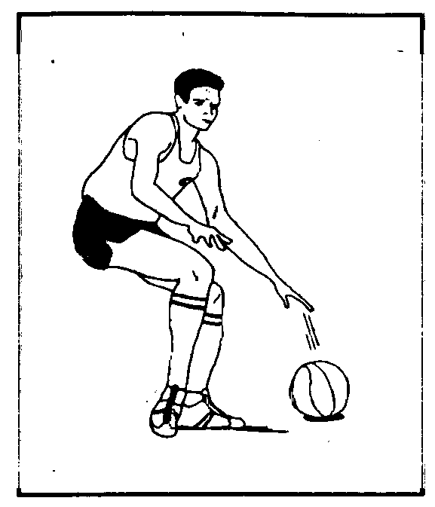
THE HIGH OR SPEED DRIBBLE
When a player is in the open court and needs to go as fast as he can with the ball, he uses the high/speed dribble. In such case the dribble is not closely guarded and while running fast, he pushes the ball in front of him and lets the ball bounce at hip level. With this type of dribble the dribbling hand is not directly over the ball as in the low dribble, but behind it. | 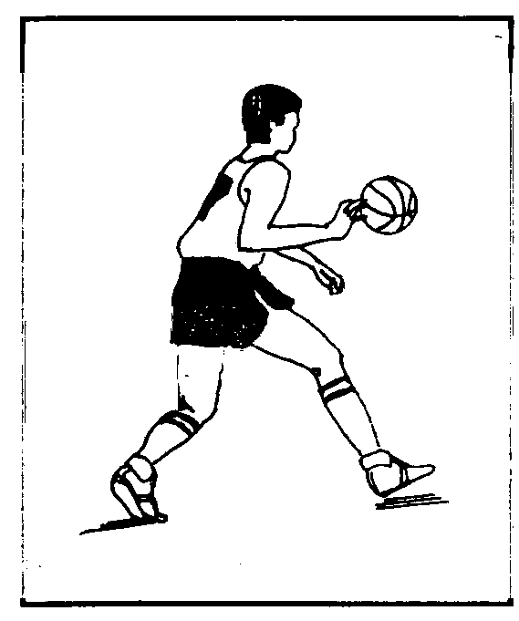
THE CROSSOVER DRIBBLE
The crossover dribble entails dribbling with one hand, then, as the dribbler get close to his defender, pushing the ball out in front of him, over to the other hand, and exploding past him. This move is a very good way to beat the defender, but, since the ball is unprotected as he makes the crossover, it can be stolen by the defence if the move is not done smoothly. | 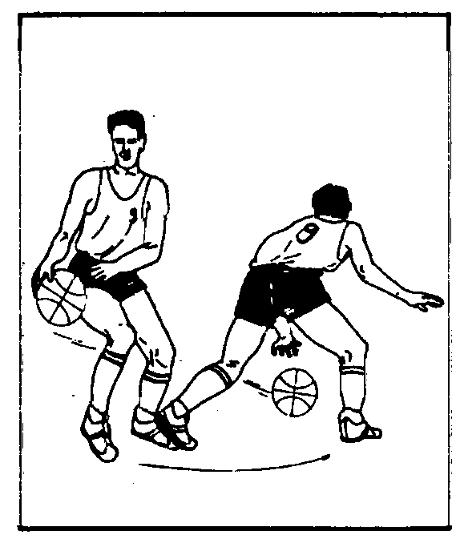
THE BEHIND-THE-BACK DRIBBLE
The type of dribble is used when the dribbler changes direction in order to get loose from his opponent. The dribbler moves the ball from one side of his body to another by swinging it behind and across his back. | 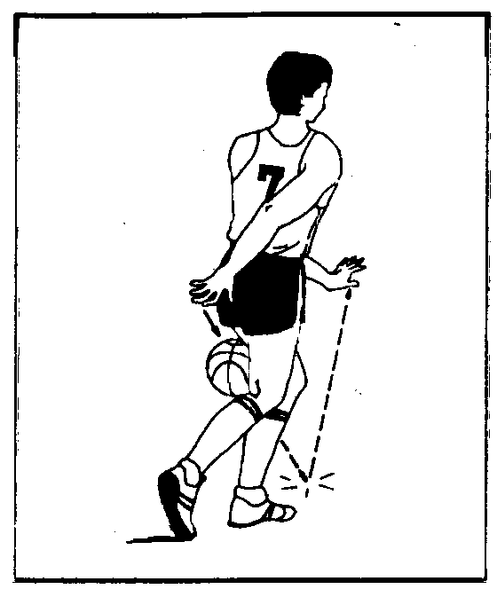
THE BETWEEN-THE-LEGS DRIBBLE
This dribble is a quick way to move the ball from one hand to another between the legs when a dribbler is closely guarded or when (being overplayed and) he wants to change direction. | 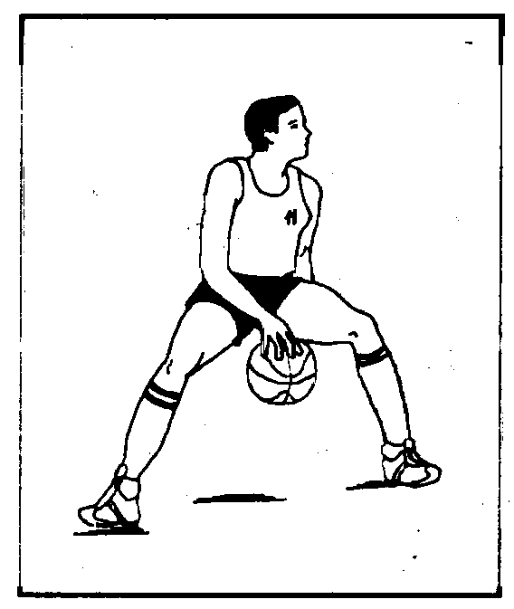

THE REVERSE DRIBBLE
This dribble (also called spin dribble or roll dribble) is also a type of dribbling to change direction and to bounce the ball from one hand to another when the dribbler is closely guarded. To use it effectively it must be executed quickly when the dribbler pushes the ball to the floor and rotates around defender. | 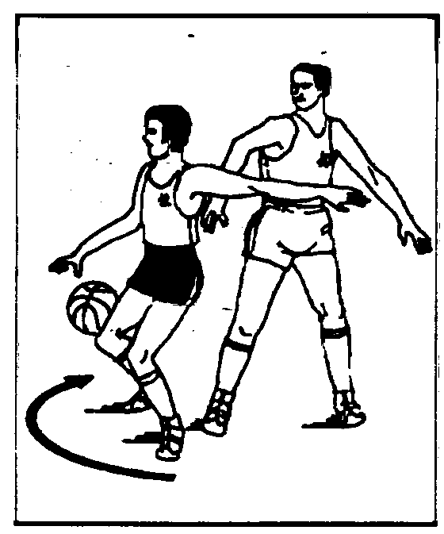
PASSING
THE TWO-HANDED CHEST PASS
The chest pass is the most common pass in a game when there isn’t a defensive player between the passer and his team mate. To execute this pass, the ball is held in two hands chest-high and close to the body. The elbows are tucked and fingers spread around the ball. As he releases the ball, arms and hands are extended with the palms turning outward. This is the most accurate of the various passes. | 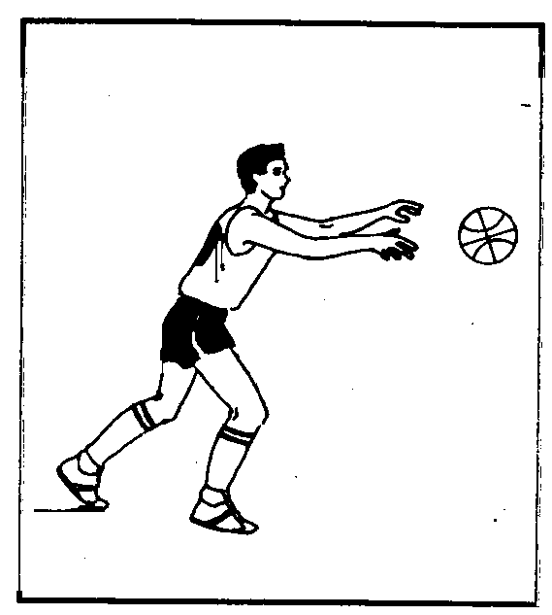
THE TWO HANDED BOUNCE PASS
The basic mechanics of the bounce pass are the same as those of the chest pass, although the situation when it is used are not. A bounce pass is used most often in pivot plays when the passer is passing to a team mate guarded from behind, or in other situation when the chest pass cannot be used. | 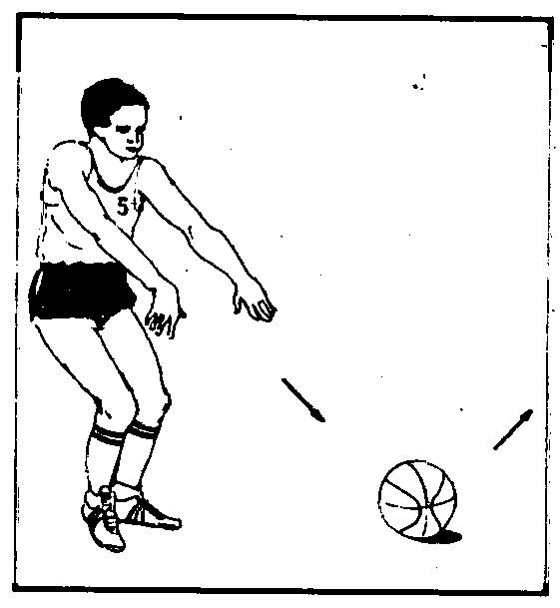
THE TWO-HANDED OVERHEAD PASS
The two-handed overhead pass is commonly used for passing the ball into the high and low post area, or as an outlet pass directly off a rebound to begin a fast break, or during a throw-in. | 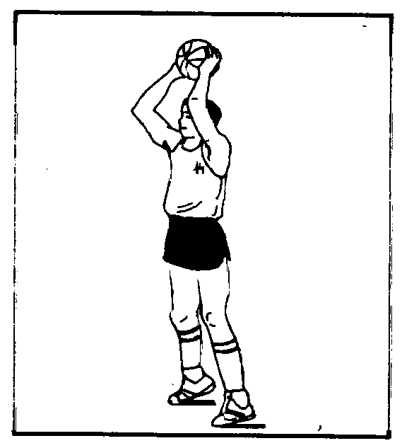
THE ONE-HAND (BASEBALL) PASS
The one-hand (baseball) pass is a long-distance pass that is usually thrown more than half the court length. This pass is not too accurate but is useful in getting the ball for a fast break. | 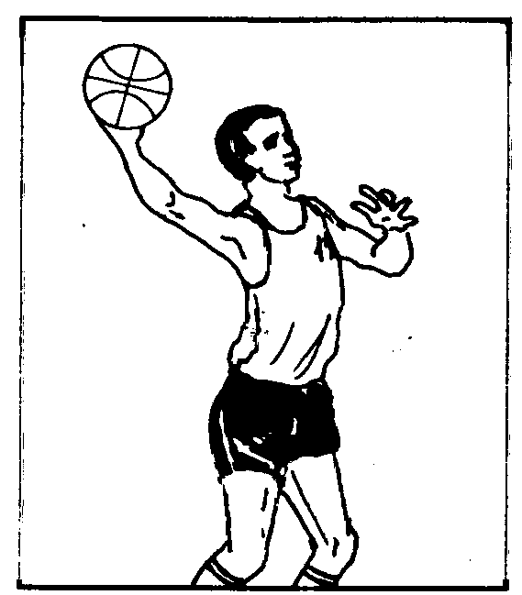
THE ONE-HAND ( PUSH ) PASS
The one-hand (push) pass is a quick pass made with one hand tо a short distance. The pass originates near the ear and relies on elbow being bent for its power. It can be either a straight or a lob pass depending on the defensive alignment. | 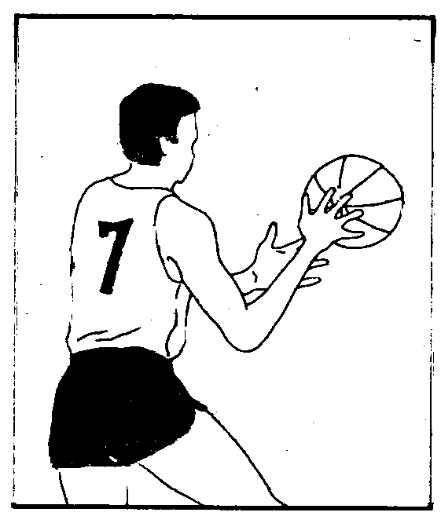
THE BEHIND - THE BACK PASS
This pass was once considered to be a fancy pass but has now become a normal offensive weapon | 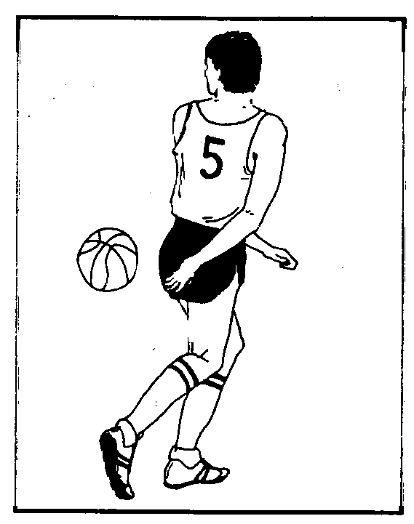
SHOOTING
THE SET SHOT
During the normal course of the game the set shot is generally not used, since if the shooter does not leap to the air the shot can easily be blocked. It is commonly used only when executing free throws, when the shooter may take an unhindered shot. | 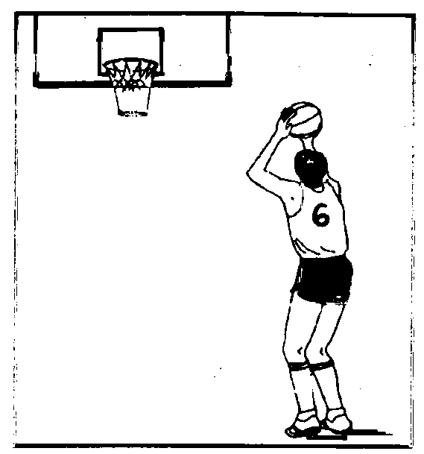
THE LAY-UP SHOT
In the game of basketball, a lay-up is the first shot that should be leamed. In a competitive situation this is the one shot that the player has to be able to make with both right and left hands. The dribble towards the basket is generally finished by a lay-up shot. When the dribbler is several feet away from the ring, simultaneously lifts his hand and the same knee up when jumping towards the basket. | 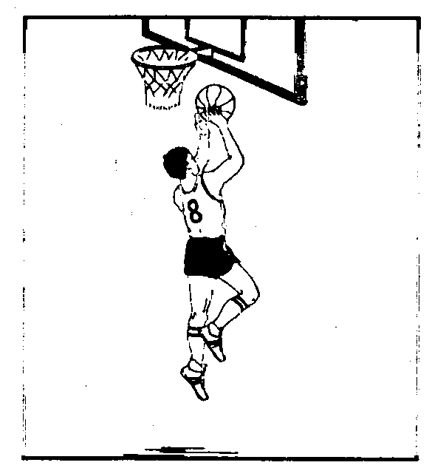
THE UNDERHAND SHOT
The underhand shot is a special type of the lay-up shot when the shooter after taking his jump towards the basket extends his arm and lifts his hand upward keeping the ball away from the defender. | 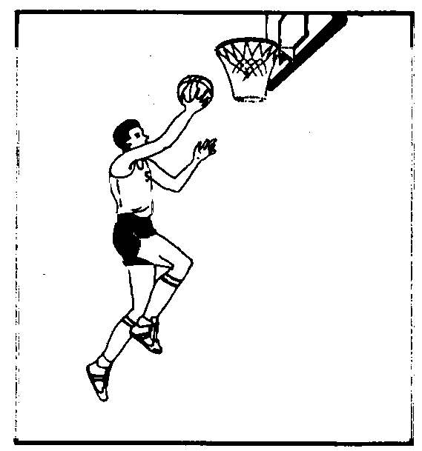

THE JUMP SHOT
Of all the shots taken in basketball game, the jump shot is the most widely used in a player’s offensive arsenal. Since fit is taken at the highest point of the shooter’s vertical jump, it is a shot that is extremely hard to block. From a long distance it is almost the only type of shot. | 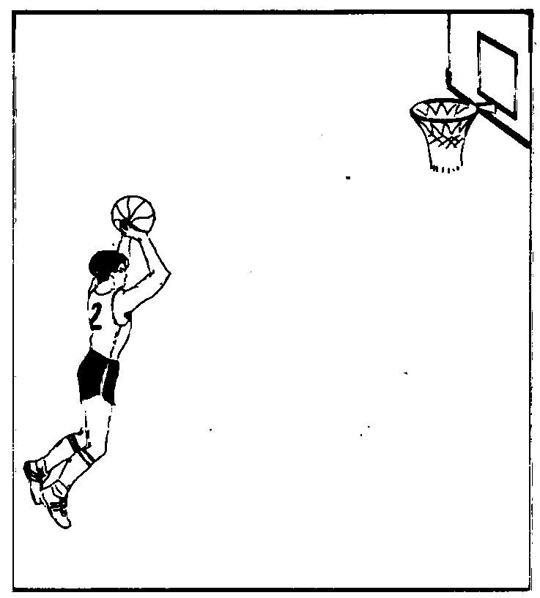
THE HOOK SHOT
The hook is a soft and accurate shot and excellent low-post move. When executed correctly, it is nearly impossible to block, because the shooting hand is away from the defender, even when guarded by a taller player.  The hook shot always starts with the shooter’s back to the basket. A good hook shot, like a good jump shot, depends on body balance. To make a righthand hook shot the player pivots on his rear (right foot) and takes a step with his left leg. Then he lifts his right knee straight up and simultaneously raises his shooting (right) hand upward and releases the ball with a flick of his wrist.  If this shot is executed by jumping from both feet, it is called jump hook. | 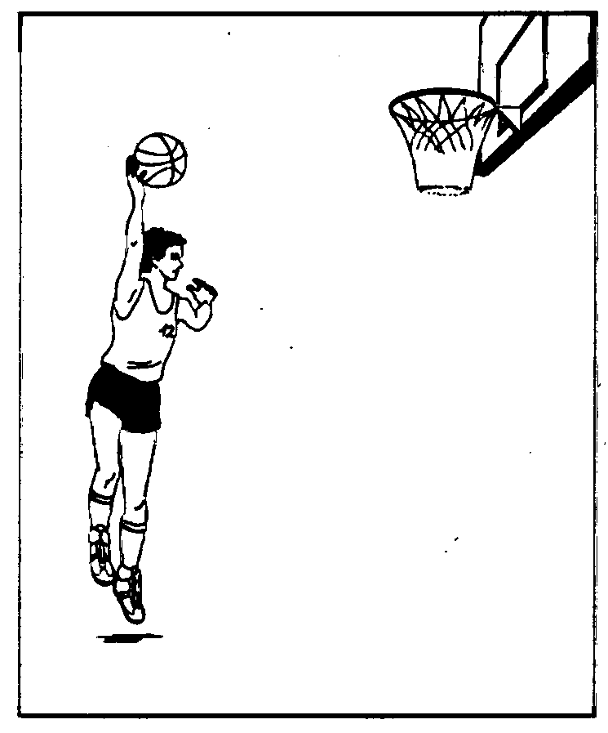

DUNKING
The dunk shot was once considered a special attraction of the tallest players. Recently, it has become common and its benefit is that the shot has no upward flight and is very difficult to block. The dunk shot is the most spectacular offensive move and it is one that can boost the team mates’ spirits and quickly demoralise the opponent. Dunking can be made by one or two hands, from in front or from behind. | 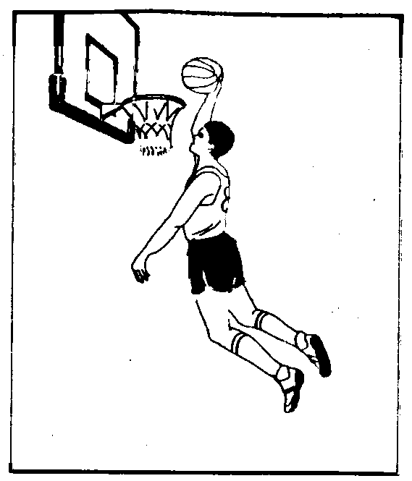
THE REVERSE LAY-UP SHOT
The reverse lay-up shot has the benefit of the rim and backboard to help protect the shooter from defenders trying to block his shot from behind. It is a good shot to use after a penetration along the end line or when he receives the ball inside the lane with his back to the basket. | 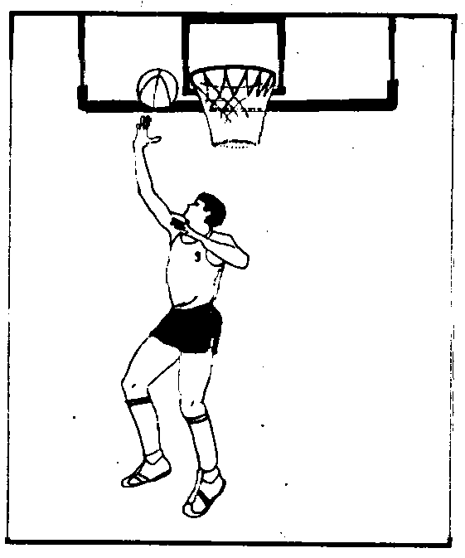
TAPPING (TIP-IN)
The tap-in is not really a shot per se. This move consists of only a soft flick of the fingertips. The fingertips are positioned under the ball as it comes off the rim and the ball is gently pushed up and tapped in the direction of the rim or backboard. Timing and good jumping ability are needed to perform this shot. | 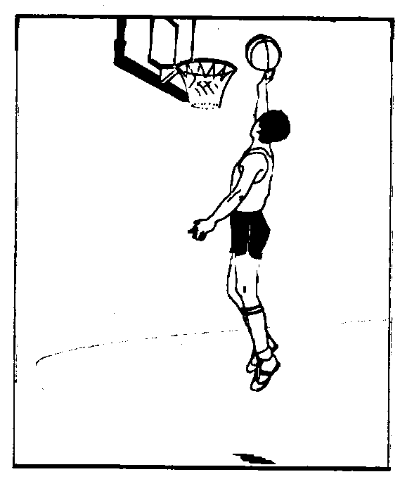

BLOCKING OUT AND REBOUNDING
Rebounding is one of the most important parts of the game. Every rebound that a player can get gives the opportunity to that team to score a basket. Since approximately half of all shots are missed, the difference in rebounding between the two teams can determine the winner. | 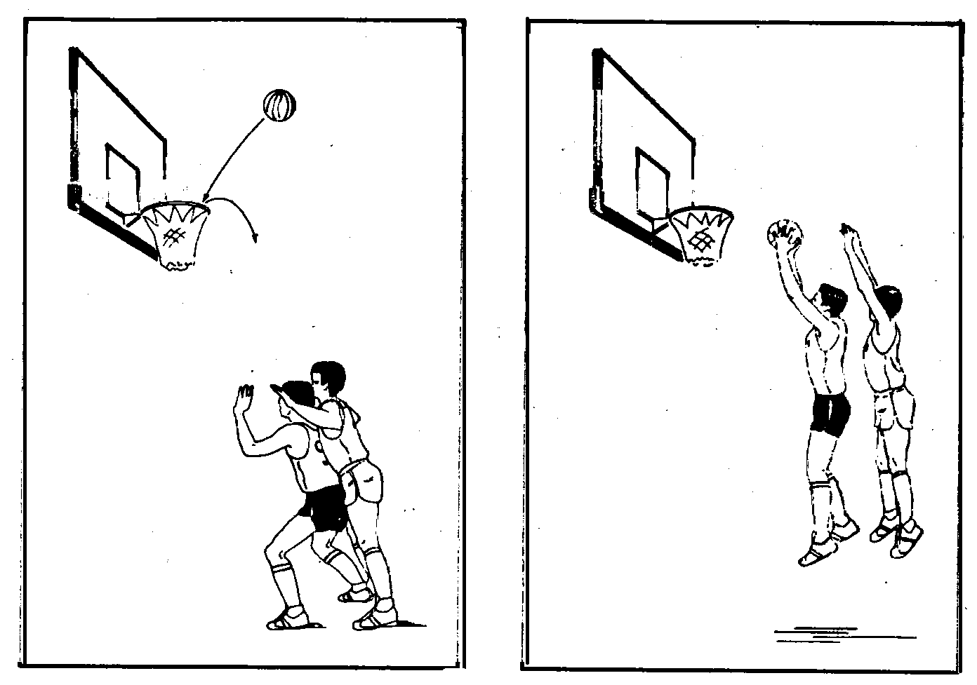
Height and good jumping ability are certainly big advantages in rebounding but they are not the only factors in becoming a good rebounder. Good position and timing are equally important. When the offensive players are blocked out by the defensive players even the shortest player can get the rebound.
SCREENING
A screen, also called a pick, is a legal block set by an offensive player on the side of or behind a defender in order to free a team mate to take a shot or receive a pass or dribble past his defender.  The screen should be set perpendicular to the direction that the defence expects to move.  The effectiveness of the screen depends not only on the screener, but also on the player who receives the screen. It’s important that the player comes close to the player making the screen. If he makes the mistake of going a step or two away from the screener, the screen will lose most of its effectiveness, especially when a good defensive man is guarding him. | 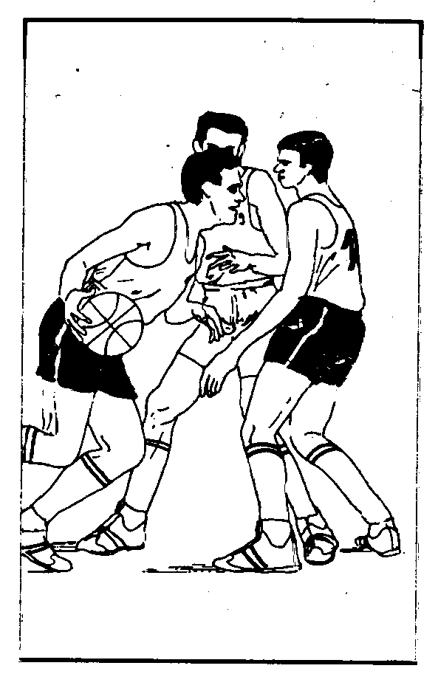
PICK AND ROLL
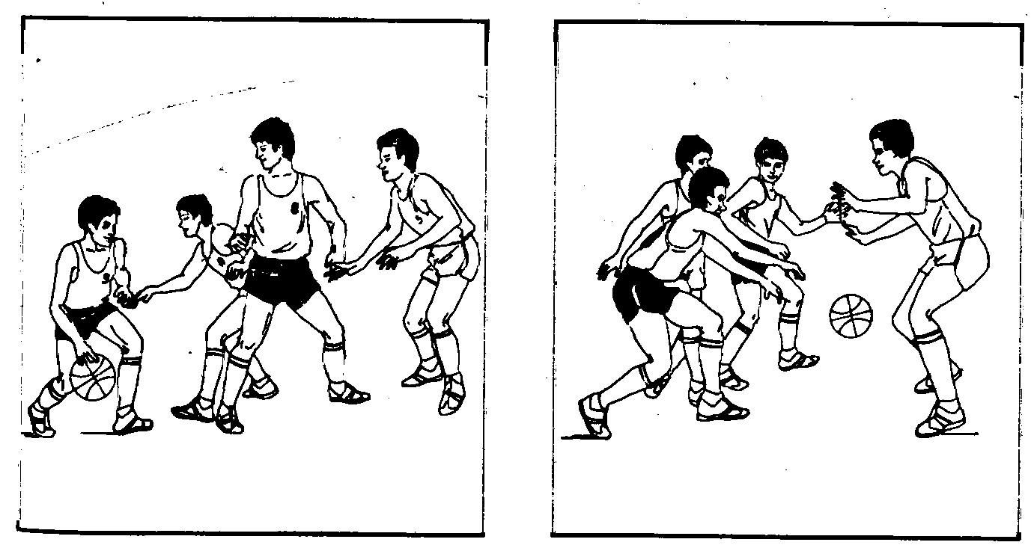
This is a combination play between the screener and his team mate with the ball. Its essence is that after the screener has set a screen, he makes a tum and looks to receive a possible pass. If it is well executed and he receives the ball, generally, he is in a very good scoring position.
This type of play is one of the most often used ones against the man-to-man defence.
DEFENCE
To play good defence the elementary fundamental to master is footwork. The defender shall anticipate his opponents by moving his feet, so as to establish legal guarding position in the path of his opponent.
MAN-TO-MAN DEFENCE
In basketball the most often used defence is the man-to-man defence. In this defence each player guards an opponent. This type of defence requires every player to play good defence because, if one of the defensive players makes a mistake his opponent can easily score a basket. Against this defence the pick and roll combination plays are often effective, sometimes resulting in very dynamic plays. In NBA the teams are only allowed to play man-to-man defence. | 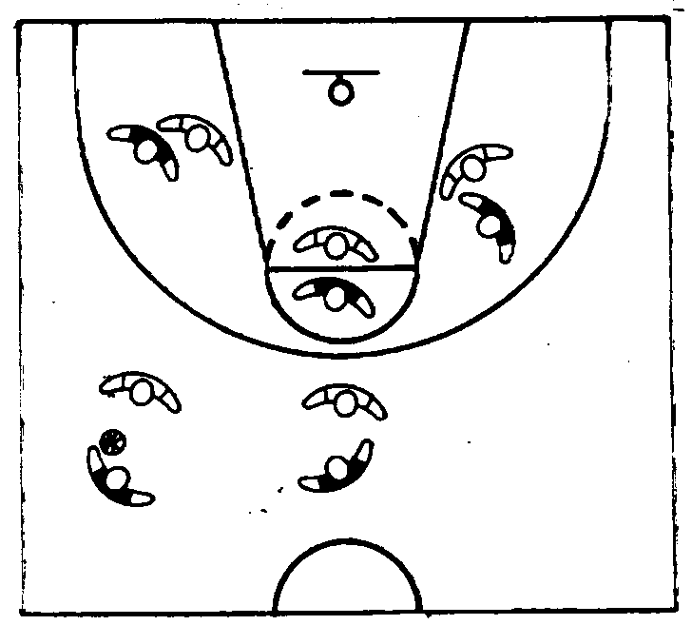
ZONE DEFENCE
When using this defence the defenders are not guarding every opponent individually but they guard a specific area (zone) around the basket. The defensive team’s moves do not directly mimic the opponents but remain in a defensive pattern as they follow the path of the ball. Every player has his own position. It is generally used when the defensive players are tall but not as quick as their opponents. Against this type of defence pick and roll combinations cannot be used because the defenders do not follow a player without the ball. | 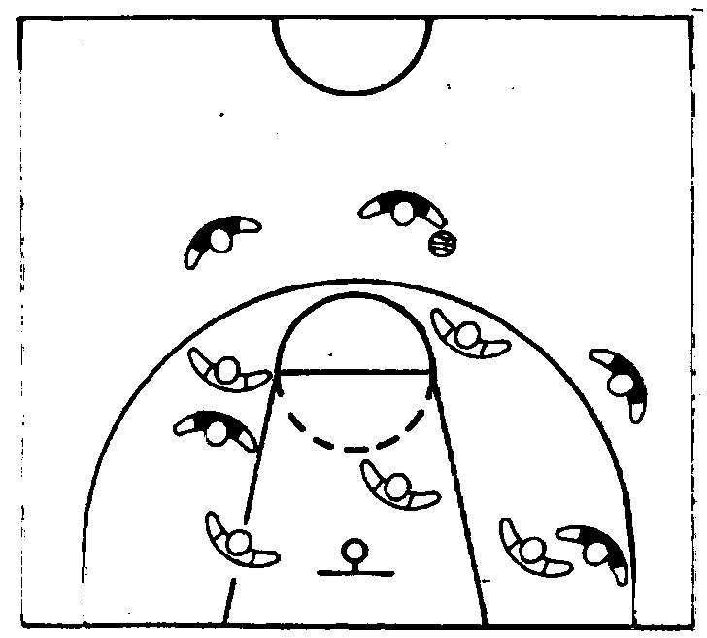
Vocabulary and Speech Exercises
Ex. 1. Continue the lists:
Dribbling: high dribbling, ...
Passing: push pass, ...
Shots: jump shot, ... .
Ex. 2. Replace the following Russian words and word-combinations by their English equivalents from the text:
основные элементы, передача мяча двумя руками с отскоком от пола, дриблинг с переводом за спиной, контролируемый дриблинг, поворот с мячом, передача мяча двумя руками от головы, расстановка игроков, бросок мяча с места, бросок мяча в движении сверху, бросок мяча в прыжке, бросок мяча в корзину, заслон, блокирование, бросок крюком, передача из-за спины, перекрёстный дриблинг.
Ex. 3. Explain the terms used in basketball:
- change of pace dribbling
- high dribbling
- crossover dribble
- reverse dribble
- two-handed overhead pass
- set shot
- jump shot
- dunking
- blocking out
- screen
Ex. 4. Find proof in the text to support the following statements:
- There are three basic ways to move the ball.
- All players should learn to dribble.
- Rebounding is one of the most important parts of the game.
- The effectiveness of the screen depends not only on the screener.
- To play good defence the elementary fundamental to master is footwork.
Ex. 5. What do you think about:
- basic elements of basketball;
- types of dribbling;
- types of passing;
- types of shooting;
- pick and roll.
Ex. 6. Give extensive answer to these questions:
1. How many basic ways to move the ball are there in basketball? 2. What must a player do while dribbling? 3. When is the low dribble used? 4. When is the high dribble used? 5. What is the reverse dribble used for? 6. What are the basic mechanics of the two-handed chest pass? 7. How is the one-hand pass made? 8. What shot should be learned by a basketball player first? 9. What movements does tapping consist of? 10. What is screening?
Ex.7. Speak on:
- basic elements of basketball;
- basic ways to move the ball;
- types of dribbling;
- types of passing;
- types of shooting.
Task YII. Read and learn the following words and word-combinations to text 6:
occupy v  evolve v  peach basket  nail v  janitor n  ladder n  eliminate v  deftness n  divert v  stepladder n  pave the way  elaborate v  revise v | занимать  выделять, намечать  корзина для персиков  прибивать (гвоздями)  сторож  лестница  упразднить  ловкость  развлекать  стремянка (лестница)  проложить путь  разрабатывать  пересматривать
Task VIII. Read text 6 as fluently as you can
TEXT 6. A SHORT HISTORY OF BASKETBALL
The history of basketball dates back a hundred years to 1891, Springfield, Massachusetts, USA.
At that time Dr.James Naismith (born Nov.6 1861 - died Nov.28 1939) was the physical educator in the School for Christian Workers (now Springfield College). As the coach of the school football team he was given the task to create an interesting indoor game to occupy the students during the winter months. In a fortnight he came up with the basic rules of a new game. Mr.Naismith evolved 5 basic principles when created the rules.
- The game is played with a round ball and with the hands.
- A player cannot run with the ball.
- Any player can take up any position on the playing court at any time.
- There shall be no physical contact between players.
- The goal (basket) shall be placed horizontally above the floor of the court.
He chose two wooden peach baskets and nailed them to the side of the balcony of the hall. The height where the baskets were hung was dictated by the height of the balcony. This height (10 feet) was so ideally selected that it has never been changed.
The first games were played with a football ball and a janitor sat on a ladder to retrieve the ball from the basket when a player made a goal.
The new game became a big success. The 13 Naismith’s original basketball rules were based on the principle that the points are to be attained by deftness rather than force. The rules were published in «Triangle» magazine in 15 January 1892 under the title «A New Game».
The first publicly played game of basketball was played in March 2, 1892 between students and teachers at the Springfield Collage. The students won 5-1 before a crowd of over 200.
Basketball began its world-wide movement as the game was then introduced in Mexico.
In the same year Lew Allen of Hartford, Connecticut made cylindrical baskets of heavy woven wire to eliminate Naismith’s peach baskets. The rims were hung at the balcony and some spectators amused themselves by diverting the ball away from the hoop. To protect the ball from spectators, first backboards (3.60 x 1.80 m) were introduced.
The ball itself outgrew the football ball and was replaced by an official basketball in 1894. In the next year a 1.80 x 1.20 m backboard was approved. Free throws were introduced.
A new rim was invented. It consisted of a net suspended on a rim and with a rope attached to the bottom of the net. When the rope was pulled the ball was released and the days of the stepladder came to an end.
On March 22, 1893 the first women’s match took place in Northampton. No men were allowed to watch the game.
From 1896 field goals were changed to 2 points, free throws to 1 point.
The same year Chicago and low competed in the first college match. Five players were allowed on each team. Chicago won 15-12. Neither team used substitute players.
Dr. James Naismith controlled the rules until 1896. Since 1896 the Amateur Sports Federation had been in charge of the rules and any changes. The Federation ruled in 1897 that a team should consist of five players and it was universally accepted. Before this ruling it sometimes occurred that up to 50 players on each side were on the floor.
By 1905 basketball had become widely spread in secondary schools, universities, church clubs and military barracks. Many students from abroad studied at the Springfield Sports School at the time when basketball was being born. They spread the new game across the ocean. Basketball was brought to Europe, more specifically to France, by the Springfield student Mel Rideout.
In 1909-1910 glass backboard was first approved in the rules. A player was disqualified upon committing his fourth personal foul.
With the arrival of the First World War the game’s growth slowed down. During that time the American soldiers and sport coaches, including Naismith himself brought to Europe the innovations of the game.
The first Inter-Allied Games were played in 1919 in Paris. This competition was won by the USA who defeated France and Italy. It is considered to be the first
international basketball tournament and paved the way for World Championship and Olympic recognition. In 1923 the designated foul shooter was eliminated, the person fouled had to shoot the free throw. At the Olympic Games in Paris in 1924 basketball was played as exhibition.
In 1927 Abe Saperstein organised the Harlem Globetrotters. The players were from Chicago and they played their first game in Hinckley, Illinois. Since that time they have contributed greatly to increase the popularity of basketball throught the world, playing in about 100 different countries. Their superior and offen amusing basketball skills continue to draw the attention of all ages.
Until 1932 we can mainly speak about American basketball rules. The rest of the world was developing under the influence of the local enthusiasts with certain fashionable additions coming from the States.
The rules were not standardised internationally. The World YMCA Committee in co-operation with Springfield College established an International School for Physical education in 1927 in Geneva. It convened a conference of the representatives of basketball associations in 18 June 1932 in Geneva and the International Amateur Basketball Federation (FIBA) was founded by eight countries. The first President of FIBA: Leon Bouffard (Switzerland), Secretary General: Renato William Jones (Great Britain).
At the FIBA Founding Congress the first international rules were elaborated.
Each team consisted of five players and 2 substitutes who could come into play twice during the game. Following every point scored from the field or from a free throw the game continued by a jump ball at the centre. The rules were basically the same as in the USA with a few changes. It was decided that the rules would be revised every four years, years of the Olympic Games. This revision would be carried out by the Technical Commission.
The first European Championship for Men was held in 1935 in Geneva. Ten national selections took part and the first European Champion was the team from Latvia defeating Spain 24-18 in the final.
In 1935 the International Olympic Committee in Oslo officially approved basketball for the Games in Berlin. It was the first great basketball tournament at which the uniformity of the game had to be proven. USA defeated Canada 19-8 (in the rain) for the Gold medal. Dr. James Naismith was among the spectators and presented medals to champions.
In Berlin the FIBA Congress brought changes into the rules in order to keep the balance between the defence and the offence, and limiting the advantage of taller players. Three time-outs were allowed. The centre jump after each score was eliminated. The ball was brought into play at the end line. It was a revolutionary rule when the court was divided into two halves and the 10 second rule went into effect. The player who collected four personal fouls was disqualified. The number of substitutes was increased to five.
Dr. James Naismith inventor of basketball died in Lawrence, Kensas 28 Nov. 1939.
There was a long interval following the Berlin Olympics, and because of the Second World War the next Congress only met in 1948, in London.
The Cup of the European Champion Clubs is introduced for men in 1958, and for women in 1959.
The professional NBA league was founded in 1949. In 1950 the first World Championship for men took place in Argentina and the first European Championship for Women in 1953 in Chile. It was a historical decision when FIBA opened the Olympic Games for the American professional players in Barcelona, 1992. At the beginning of the century basketball is the game which is played and enjoyed by more than 250 million registered players all over the world. It has become the game of the modern times.

Notes
- Springfield, Massachusett, USA - Спрингфилд штат Mассачусет (США)
- James Naismith - Джеймс Найсмит
- «Triangle» - журнал «Треугольник»
- FIBA - International Amateur Basketball Federation
Assignments
Assignment 1. Answer the following questions. If necessary, look through the text again:
1. Who invented basketball? 2. What basic principles did J.Naismith evolve when created the basketball rules? 3. What was nailed to the side of the balcony? 4. What were the first games played with? 5. What principles were the original basketball rules passed on? 6. Where were the first rules published? 7. Where and when was the first game of basketball played publicly? 8. When did basketball begin its world-wide movement? 9. When was the football ball replaced by the basketball one? 10. Who was in charge of the basketball rules and their changes? 11. When was FIBA founded? 12. Where were the first international basketball rules elaborated? 12. When was basketball approved for the Olympic Games?
Assignment 2. Reread paragraph 2. Entitle the paragraph. From the list below choose the heading which suites its theme best:
- The father of basketball.
2. A diverting indoor winter game.
- Basketball invention.
- Springfield College.
Assignment 3. Which is the most important sentence expressing the main idea in paragraph 15? It may be called the key sentence (Summe rising the information contained in the whole paragraph). Find the «key» of paragraph 15.
Assignment 4. Reread paragraphs and say:
- which the most important sentence expressing the main idea of paragraph 25 is;
- the name of the body that would revise the basketball rules.
Assignment 5. Find the passage desribing the first international basketball rules.
Assignment 6. Give some information:
- about the origin of basketball;
- evolution of the ball;
- FIBA;
- about the game of the modern time.
Refereeing
Task YIII. Before you read the text:
- Say:
- how many officials there are in every competition;
- what the referees do to start the game;
- learn the following words and word-combinations:
officials n  official n  referee n  umpire n  timekeeper n  scorer n  30 second operator  impartial a  infraction n  set aside v  question v  offender n  resume v  inspect v  approve v  recognize v  disagree v  warrant v  forfeit v  restore v  expiration n  precedence n  jump ball  designation n  trail official  lead official  coverage n  perepheral vision n  be unsure  score sheet n  pertain v  notify v  marker n  scoreboard n  discrepancy n | состав судей  судья на поле  старший судья  помощник главного судьи  судья секундометрист  секретарь  cудья хронометрист  справедливый  нарушение  отвергать  оспаривать  нарушитель  возобновлять игру  проверять  утверждать  признавать  расходиться во мнении  давать право  отменять (игру)  возобновлять  истечение (времени игры)  преимущество, первенство  спортивный мяч  указание, назначение  судья, наблюдающий (следящий за мячом)  судья, следящий за игроками  зона действия  периферическое зрение  быть неуверенным  таблица очков  иметь отношение, касаться  сообщать  знак, карточка  табло  разногласие
Task IX. Read text 7. Pay attention to the officials, their assistants, their duties, and responsibilities
Text 7. Refereeing
Officials
The officials are a referee and an umpire. They shall conduct the game in accordance with the rules and official FIBA interpretations of such rules.
The officials shall be assisted by a timekeeper, a scorer and a 30 second operator. They are sitting at the table. In order to operate the scoreboard an assistant scorer may also sit at the table.
It is very important that the referee and the umpire of a given game should not be connected in any way with either of the teams represented on the court and they should be thoroughly competent and impartial.
None of them have authority to agree to changes to the rules. The officials shall wear a uniform consisting of grey shirt, long black trousers, black basketball shoes and black socks.
DUTIES AND POWERS OF THE OFFICIALS
General duties and powers of the officials
Both referee and umpire have powers to make decisions for infractions of the rules.
Neither official shall have the authority to set aside or question decisions made by the other. However, the referee has greater duties, powers and responsibilities in some cases. Such as prior to the game, at the end of the game, about time and score or when the two officials disagree upon whether a goal counts or not, etc.
When a violation or foul occurs the official shall blow his whistle to stop the play and signal the timer to stop the clock. After a field goal or a goal resulting from a free throw they shall not blow their whistle, but shall clearly indicate that a goal has been scored. If a personal foul occurs he shall also indicate the number of the offender, the type of the foul and indicate how the game will be resumed. When a team is entitled to a throw-in an official shall clearly signal the act which caused the ball to become dead, the direction of play to follow, unless it follows a successful goal or an awarded goal.
After each foul or jump ball decision the officials shall exchange their position on the court.
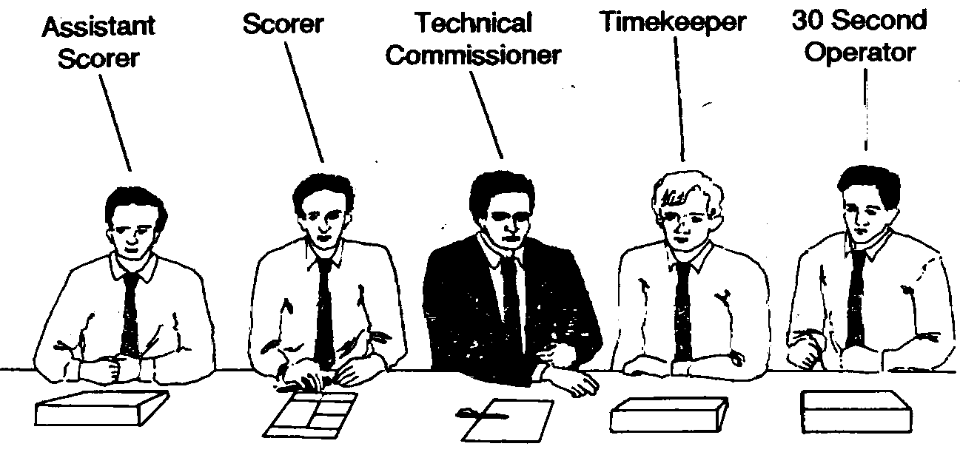
SPECIAL DUTIES AND POWERS OF THE REFEREE
The referee shall, prior to start of the game:
- inspect and approve all equipment, including all the signals used by the
- table officials;
- inspect and approve the court, baskets and backboards;
- select the game ball;
- recognise the scorer, timekeeper and 30-second operator.
The referee shall toss the ball at centre to start the game. He shall have the power to stop the game when conditions warrant it.
He shall determine that a team shall forfeit the game if it refuses to play after being instructed to do so by the referee or if the team, by its actions, prevents the game from being played.
He shall decide matters upon which the timekeeper and scorer disagree.
At the end of each half and of each extra period, or at any time he feels it necessary, he shall carefully examine the scoresheet, approve the score and confirm the time that remains to be played.
His approval at the end of the game terminates the connection of the officials with the game.
The referee shall have the power to make decisions on any point not specifically covered in the rules.
TIME AND PLACE FOR DECISIONS
The officials shall have powers to make decisions for infractions of rules committed either within or outside the boundary lines, such as the floor surrounding the court, including team bench and scorer’s table area. They have no direct power on the auditorium, dressing room, etc. If there is any problem concerning the behaviour of the spectators, it is the task of the organisers to help them or restore order.
These powers shall start when they arrive on the court, which shall be twenty minutes before the game is scheduled to begin, and shall terminate with the expiration of playing time as approved by the referee.
DIFFERENT DECISIONS BY OFFICIALS
Normally, the two officials, depending on their position on the court, have different responsibilities. With a good cooperation they can avoid the situation that leads to make different decisions. However, it sometimes can happen that the two officials make different decisions at approximately the same time.
In such cases the principles are as follows:
- if the officials disagree as to who caused the ball to go out-to-bounds a jump ball shall be called between the two involved players. However, one of the officials may withdraw his decision if he has been satisfied that his partner was in better position to make the right decision;
- if one of the officials calls violation and the other calls foul at the same time, the stronger call, the foul will take precedence. However, if they agree that the violation occurred before the foul, the violation shall be penalised and the foul shall be disregarded, unless it was technical, unsportsmanlike or disqualifying foul, in which case it will be penalised;
- if both officials are calling fouls on two different players from the same team, they shall determine which foul occurred first and penalise it accordingly; the second foul shall be disregarded, unless it was technical, unsportsmanlike or disqualifying foul, in which case it will be penalised as well;
- when, after a foul, a successful goal is scored the official who called the foulshall decide whether the goal counts or not. If both officials call the foul, generally, the nearest, official or the official towards whom the play is moving, takes the call (goes to the scorer’s table), and decides whether the goal counts or not;
- when a foul is called, the official calling the foul shall decide whether the fouled player was in the act of shooting or not, and the game will be resumed by free throws or by throw-in. If both officials call the foul, generally, the near-rest official or the official towards whom the play is moving, takes the call (goes to the scorer’s table), and decides the resuming of the game. If the two officials disagree the referee’s decision takes precedence;
- the responsibility to decide whether a goal counts 2 or 3 points is on the trail official. When there’s a shot near to the lead official he shall help his partner, but the trail official shall give the signal to the scorer’s table;
- in the event when time expires or 30 second signal sounds and the officials disagree whether the goal counts or not, the referee shall decide.
MECHANICS AND OFFICIATING TECHNIQUES
Positioning of Officials
During the game the two officials, generally position, themselves so that they are on the left side of the players and the ball, and they can see each other on their right diagonally.
As play progresses up the court an official should take a position behind (and to the left), and he is called «trail official», the other official should always be ahead of the play, and he is called «lead official».
The two officials position themselves so that the ten players are between them (boxing-in principle).
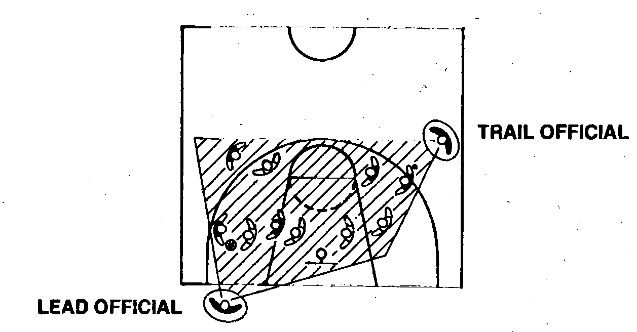
As the direction of play changes the two officials follow the ball and the lead becomes trail, the trail becomes lead official.
After each foul and jump ball decision the two officials shall exchange their position.
There are two different designations for officials to each game: Referee and Umpire. There are two different positions on the court: Lead and Trail. Do not interchange the positions and the designations. At one time the referee is in lead position at another time he is in trail position.
DIVISION OF RESPONSIBILITIES ON THE COURT
Good officiating requires the two officials to work in cooperation with each other, one referee taking responsibility for on-the-ball coverage and the other away the ball.
In order to achieve proper coverage, the two referees shall seek to obtain the best possible position from which to judge the play.
To simplify this, the half of the court has been divided into rectangles, number 1 to 6. Depending on the position of the ball the two officials have different responsibilities. One of them shall primarily watch the ball and the play around it; the other has the primary task to watch the play away from the ball. He shall also know where the ball is located but it is not the same as watching the ball.
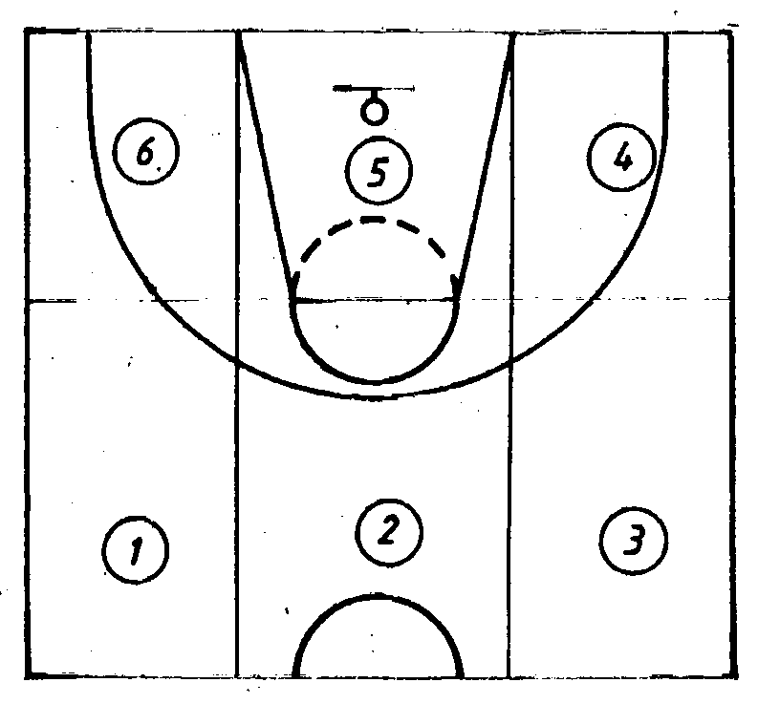
The trail official has primary responsibility on the ball and the play around it when the ball is located in rectangle 1,2,3,5 and 6; the lead official when the ball is in rectangle 4 and 5. The rectangle 5 is the only area where both referee have the same primary responsibility. It is statistically proved that the most of the fouls are committed in this area.
The position of the ball dictates whether an official referees on the ball or off the ball.
An official, when the ball is not in this primary responsibility area, must utilize his peripheral vision.
The play that everyone watching the game can see, must be called. It does not matter if it occurs in an official’s primary area of responsibility or not. If the official not primarily responsible for the action knows (not guesses) what has occurred, he may, or even, he must call it.
RESPONSIBILITY FOR THE LINES
Each official has specific responsibilities for the boundary lines. The trail official is primarily responsible for the sideline to his left and the centre line. He shall call the out-of-bounds on his side line and the back court violation.
The lead official is primarily responsible for the sideline to his left and for the end line. He calls when the ball goes out-of-bounds at these lines.
Normally both officials call for the line that is directly concerned with his primary responsibility. The other official should not interfere, unless his partner is unsure of the decision. This will prevent conflicting decisions and jump ball situations.
THE PRIMARY DUTIES OF THE TRAIL OFFICIAL
- 2 and 3 point attempts for goal
- at an attempt for goal whether time had expired at the end of a period or a 30 second violation had occurred before the ball had left the hand of the shooter
- play above the level of the ring, goal tending and basket interference
- rebounding situations, especially watching the perimeter players
- screens both on and away from the ball
- handchecking
- low post area, especially on weak side (away from the ball)
- fouls away from lead official
- travelling violations, also near to the lead official and close to the basket
- 30 second clock
- off-the-ball coverage when the ball is out of his primary area of responsibility
- sideline to his left and centre line, ball returned to back court
- 10 second violation
THE PRIMARY DUTIES OF THE LEAD OFFICIAL
- play underneath the basket
- pivot/post play
- action in the restricted area most of the time (the only exception when the ball
- is located in rectangle 4), 3 second violations
- screens (mostly away from the ball)
- rebounding situations (pushing for rebounds)
- shooting situations close to the basket
- sideline to his left and the endlin
TABLE OFFICIALS
The officials shall be assisted by a timekeeper, a scorer and a 30 second operator. In order to operate the scoreboard an assistant scorer may also sit at the table. A technical Commissioner, if appointed by the National Federation, is also present. During FIBA events a Technical Commissioner shall always be nominated.
They are sitting at the table as it is shown on the diagram below.
Timekeeper
The timekeeper shall keep a record of playing time and time of stoppage. He shall note when each half is to start and shall notify the referee more than three minutes before this time so that he may notify the teams, or cause them to be notified, at least three minutes before a half is to start.
For a charged time-out the timekeeper shall start a time-out watch and shall direct the score to signal when 50 seconds have elapsed after the start of the time-out.
The timekeeper’s signal causes the ball to become dead and the game clock to be stopped.
He shall indicate with a very loud signal the expiration of the playing time in each half period or extra period.
Scorer
The scorer records the scoresheet made about the game.
He shall keep a record of the names and numbers of players who are to start the game and of all substitutes who enter the game.
When there is an infraction of the rules pertaining to submission of line-up, substitutions or numbers of players, he shall notify the nearest official as soon as possible after the infraction is discovered.
He shall keep a chronological running summary of points scored and he shall record the field goals made and the free throws made or missed.
He shall record the personal and technical fouls called on each player or coach and he shall notify the referee immediately when the fifth foul (for games of 2 x 20 minutes) or the sixth foul (for games of 4 x 12 minutes) is called on any player. He shall indicate the number of fouls committed by each player. Every time a player commits a foul, he shall raise, in a manner visible to both coach, the marker with the number corresponding the number of fouls committed by that player.
He shall record the time-outs charged to each team and shall notify the coach through an official when he has taken the second time-out (for games 2 x 20 minutes) or third time-out (for games of 4 x 12 minutes) in each half.
Whenever possible, the scorer should check his running score with the visual scoreboard. If there is a discrepancy and his score is correct, he shall immediately take steps to have the scoreboard corrected.
30 second operator
The 30 second operator shall operate the 30 second device or clock. He measures the time of team control on the court.
If a team in control of the ball fails to shoot for goal within 30 seconds, this shall be indicated by the sounding of the 30 second signal.
The 30 second operator must know well the rules concerning of control of the ball, especially team control.
The signal of the 30 second operator shall be different from that of the scorer and the timekeeper.
The signal should sound automatically when the digital count down type of device reaches «Zero», and should effect the stop of the game clock automatically as well. The signal causes the ball to become dead. The 30 second device shall be started by the operator as soon as a player gains control of a live ball on the court. The 30 second device shall be stopped as soon as team control is ended.
ASSISTONT SCORER
TECHNICAL COMMISSIONER
Vocabulary and Speech exercises
Ex. 1. Find Russian equivalents for the following English words:
- officials  - umpire  - referee  - expiration  - infraction  - jumpball  - scoreboard  - coverage  - scoresheet  - discrepancy | - старший судья  - нарушение  - состав судей  - помощник главного судьи  - спорный мяч  - истечение  - таблица очков  - табло  - зона действия  - разногласие
Ex. 2. Try to match these words with their meanings:
offender | an official taking position ahead of the play
impartial | to see that rules are obeyed
restor | fair
inspect | resume
disagree | give notice of
expiration | an official taking position behind (and to the left) of the ball
notify | take a different view
set aside | coming to an end
lead official | one who has been guilty
trail official | reject
Ex. 3. Name the following in English:
- состав судей
- судья поля
- старший судья
- помощник главного судьи
- судья секундометрист
- секретарь
Ex. 4. Speak on:
- official’s uniform
- general duties and powers of the officials
- special duties and powers of the referee
- different decisions by officials
- positioning of officials
- division of responsibilities on the court
- responsibility for the lines
- the primary duties of the trail official
- the primary duties of the lead official
- table officials
- the scorer responsibilities
- the timekeeper resposibility
- the 30 second operator responsibility
Ex. 5. Explain referees’s official hand signals.
Ex. 6. Compose the referring corps for a game.
Ex. 7. Pretend you are the referee. Tell how you will conduct the game.

Application
